**LAB 1 Report**

Student number: 12161762

Name: LEE YEONG JUN

- **ps**

ps: show all running (working) processes

<Result>

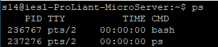

- **top**

top: display all Linux tasks

<Result>

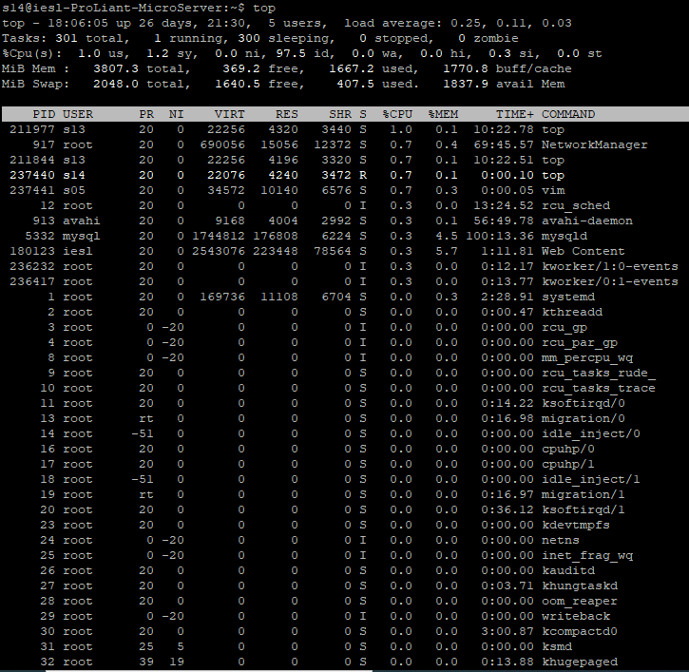

- **kill PID**

kill PID: kill the process of given PID

ex) kill 235: process will be killed of PID 235

- **killall proc**

killall proc: kill all the processes named ‘proc’

ex) killall A: process named ‘A’ will be killed

- **bg**

bg: bring currently working process to background

- **fg**

fg: bring currently working process to foreground

- **fg n**

fg –n: bring the process n to the foreground